My cousin was a chip designer at AMD and worked on the Athlon64/Opteron architecture.

From what he was saying in our discussions is that they used a powerful CAD program and each designer was given a very small section of the chip to design and optimize for efficiency by shortening the trace lengths as much as possible.

Sections of processors tend to be very repetitive and the placement of redundant sections is probably highly automated. The engineer can then spend countless hours in front of large screens to go over their section of silicon with a fine-toothed comb, moving the bits and pieces around until there is not more room for improvement.

Once a “core” design is finalized it is duplicated and the next phase takes place designing the interconnects and L3 cache to let them work together as well as possible.

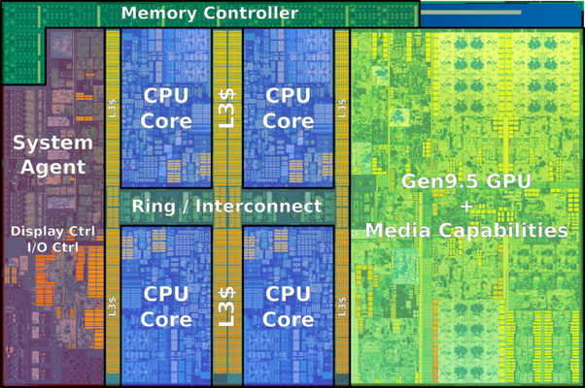

The entire Pentium 4 Processor is roughly the equivalent of one of the blue sections of this i7–7700 chip along with its own L3 cache.

This modern “Skylake” Architecture is essentially three chips in one. The “system agent” is equivalent and takes the place of the old motherboard chipset known as the **Northbridge**, which handled all the high speed I/O such as AGP and the RAM. Having this on the processor die greatly improves both speed and efficiency.

The most impressive part of the Skylake architecture is actually the GPU, which comprises close to 40% of the Skylake die. But it is actually the lowly Ring Bus that is the true hero of the modern Intel processor. Instantaneous access by all cores to the entire L3 cache, GPU, System Agent, and each other.

It is amazing to see how well the ring bus still holds up with Alder lake.

Chip designers do not start over from scratch ever time they design a CPU. The Pentium 4 evolved into the Core Duo. The Core 2 evolved into the quad. The Nehalem i7 was a complete redesign (AFAIK) but every chip made since then is an iteration of the original i7.

Gen-11 Rocket Lake was the first major chip redesign since i7 hit the streets in 2008, and contained the beefed up features designated for 10nm. When the i9–11900K came out using a staggering 250+ watts, it was because Intel was forced to manufacture it at 14nm instead of its intended 10nm.

Fortunately, Alder Lake has incorporated the enhanced Rocket Lake cores at the originally intended 10nm, along with a handful of E-cores thrown in for both core-hungry creators and for greatly improved efficiency for background tasks. There are rumors of the E-cores being beefed up Atom cores, but that rumor has allegedly been debunked.